National Symbols of India

National Flag of India – Tiranga
The Tiranga, or Tricolour, is the National Flag of India. It was designed by Pingali Venkayya and was adopted by the Constituent Assembly on 22nd July 1947.
• Saffron (top band): Symbolizes strength and courage.
• White (middle band): Denotes peace and truth, with the Ashoka Chakra (Dharma Chakra) in navy blue.
• Green (bottom band): Represents fertility, growth, and auspiciousness of the land.
The Ashoka Chakra has 24 spokes and is inspired by the wheel on the abacus of the Sarnath Lion Capital of Ashoka.
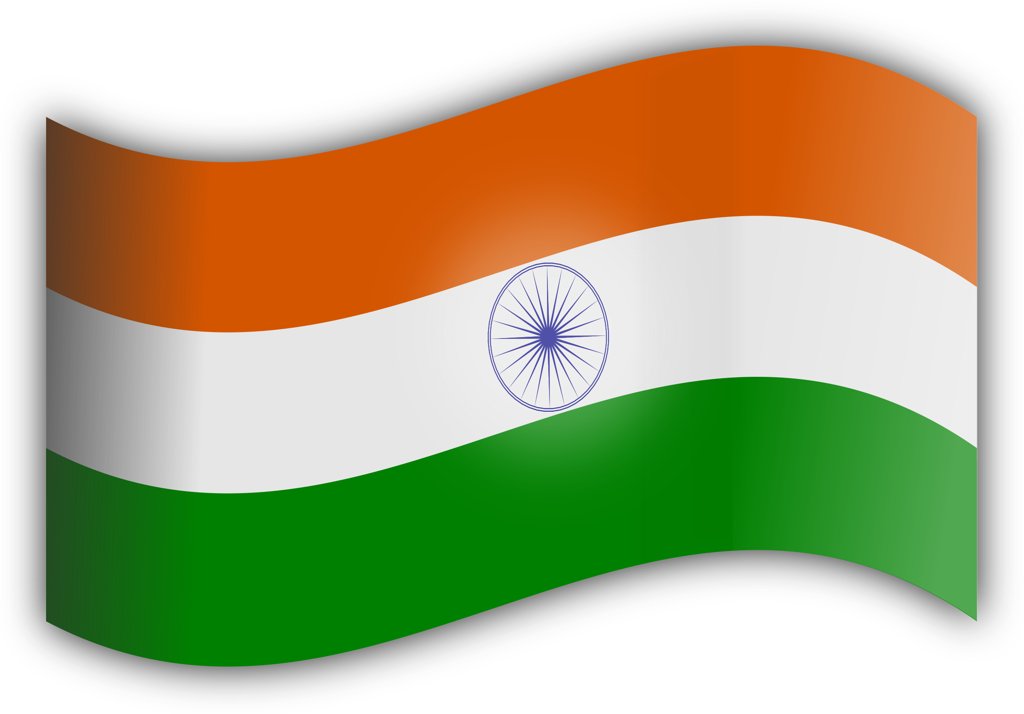

National Animal – Royal Bengal Tiger
The Royal Bengal Tiger is the National Animal of India. It was officially declared so in April 1973, replacing the Lion, to highlight the dwindling population and to promote conservation.
• Recognized for its strength, elegance, and power.
• One of the largest wild cats in the world.
• Became the face of Project Tiger, a major conservation initiative.
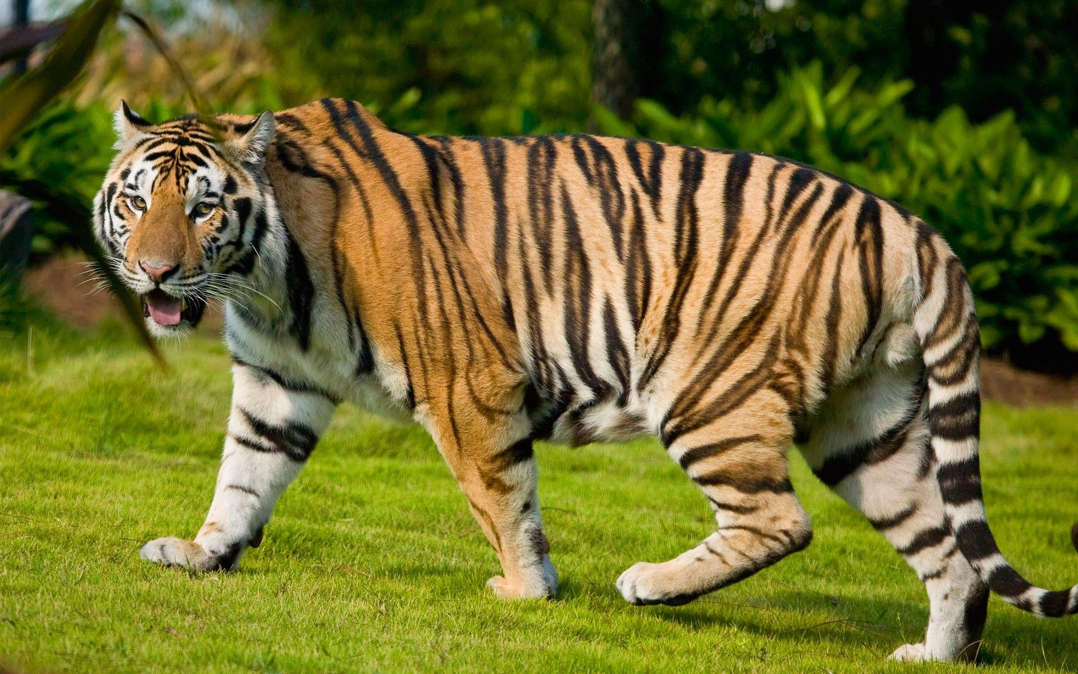

National Bird – Indian Peacock
The Indian Peacock (Pavo cristatus) is the National Bird of India, declared on February 1, 1963.
• Native to the Indian subcontinent.
• Symbolizes grace, beauty, and vibrancy of colors.
• Frequently appears in Indian mythology and art.
• Commonly found in drier lowland areas and forests.
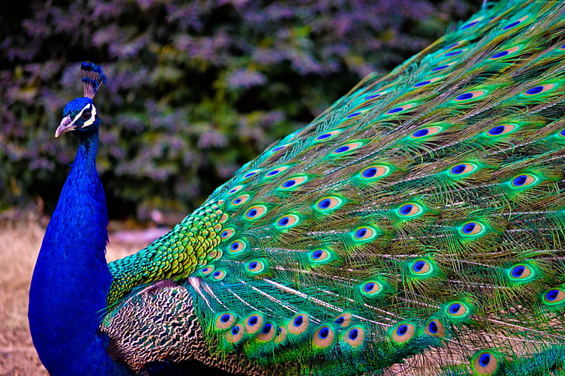
National Game – Hockey
Hockey is widely regarded as the National Game of India due to its historical significance and achievements.
• India won 8 Olympic gold medals in hockey.
• The golden era was from 1928 to 1956 with six consecutive Olympic golds.
• Also won the 1975 Hockey World Cup.
• The Indian Hockey Federation was affiliated with the International Hockey Federation in 1927.
National Currency – Indian Rupee (₹)
The Indian Rupee (₹) is the official currency of India.
• The ₹ symbol was adopted on 15th July 2010.
• Designed by combining the Devanagari letter “र” (Ra) and the Roman capital “R”.
• The two horizontal lines represent the Indian flag and also symbolize equality (=).
• Reflects India’s growing economic identity globally. 